ENGINEERING NOTEBOOK

Peter Cetner

ASSIGNED TO:

NAME: Piotr(Peter) Cetner

SIGNATURE:                                   DATE:   1/26/2023

PHONE: (585)348-1924

EMAIL:    onadeem@student.monroecc.edu    **OR** onadeem157@gmail.com

COMPANY: Monroe Community College

DEPARTMENT: Engineering Science and Physics

ADDRESS: 1000 E. Henrietta Road

CITY: Rochester STATE: NY ZIP: 14623

TEAM MEMBERS:

Piotr(Peter) Cetner: pcetner@student.monroecc.edu

Omar Nadeem: onadeem@student.monroecc.edu

Maxim Karasev: mkarasev@student.monroecc.edu

**TABLE OF CONTENTS**

|  |  |  |
| --- | --- | --- |
| PAGE | SUBJECT | DATE |
| 1-3 | Project Summary | 2/5/2023 |
| 4-5 | Grading Criteria, Weekly Goals, and Roles | 1/30/2023 |
| 6 | General Meeting #2 and Wingtip Design | 2/5/2023 |
|  |  |  |
|  |  |  |
|  |  |  |
|  |  |  |
|  |  |  |
|  |  |  |
|  |  |  |
|  |  |  |
|  |  |  |
|  |  |  |
|  |  |  |
|  |  |  |
|  |  |  |
|  |  |  |
|  |  |  |
|  |  |  |
|  |  |  |
|  |  |  |
|  |  |  |
|  |  |  |
|  |  |  |

While this Engineering Notebook is for a class, this project was started before the semester started. The purpose of this section is to detail the work done in those few weeks. I joined the project about two weeks after Maxim and Omar started, so some of the diagrams in this section are not my own.

**Project Summary**

**An introduction to VTOL:** A VTOL vehicle, which stands for Vertical Take-off and Landing, is a vehicle that has the ability to take off vertically, and transition to a forward flight mode. This has numerous benefits when compared to traditional vertical takeoff vehicles and planes.

A VTOL is very similar to a helicopter/multirotor in that they also have the ability to take off vertically. However, that is where the similarities end. After takeoff, helicopters and other multirotors remain in the same configuration. Essentially, they rely on propellors to create lift by generating a force of thrust downwards. Because of this, the only way they are able to move in a direction other than up and down is by some sort of thrust vectoring. This is inherently very inefficient, as most of the force of thrust is used to keep the vehicle up, and only a small component of the force is used for movement.

In order to improve upon this, a VTOL has the ability to transition to a forward flight mode. Essentially, it transitions into a plane, with the propellors providing a thrust force opposite the intended direction of motion. Unlike a helicopter or multirotor, the main source of lift is an airfoil. This greatly improves efficiency and top speed.

While there are numerous types of VTOL aircraft, the design chosen by our team was one with a wing-tipped motor configuration. We plan on using two motors for propulsion, and two servo motors. By using a servo motor to tilt each of the propellors in the pitch direction by ~ +/- 20°, we expect to be able to have full control of the vehicle while hovering. Then, to allow for the transition between forward flight, we will have an additional servo motor or two to allow for an ~ 90° transition in the pitch direction. This transition will not only rotate the propellors, but also the whole wing.

Although all of the parts in the assembly shown below have already been designed, their design will not be discussed unless a change is required in the future.

CONTINUED ON NEXT PAGE 🡪

**Motion Control:**

**Project Summary(Continued)**

Maxim created this diagram of how we plan to control the VTOL:

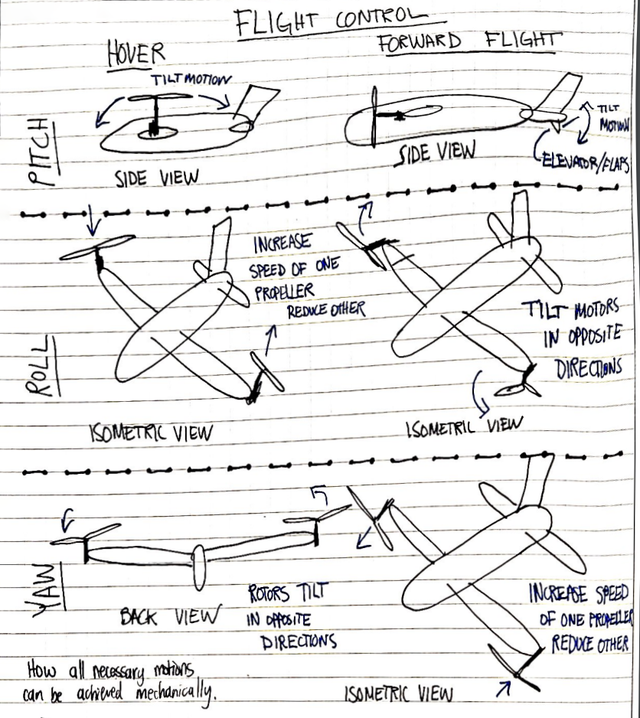

CONTINUED ON NEXT PAGE 🡪

**Flight controller:** Due to VTOL vehicles being relatively new, most consumer and hobbyist flight controllers are not compatible with VTOL vehicles. Because of this, we had to find a flight controller that would support our project, and we ended up finding the dRehmFlight flight controller, an experimental flight controller with specific compatibility for VTOL vehicles. It relies on a Teensy 4.0 microcontroller and MPU6050 6DOF IMU. We chose dRehmFlight because it has an incredible amount of clear and organized documentation. We have a flashed the controller, but have not done any coding other than that.

**Project Summary(Continued)**

**Motor Tilt Mechanism:**

Maxim created this diagram of how we plan to tilt each motor ~20°.

2/5/2023

January 29th, 2023, 7:30PM – 11:30PM

**Grading Criteria, Weekly Goals, and Roles**

Virtual meeting on Discord

**Attending**: Peter Cetner, Omar Nadeem, Maxim Karasev

**Old business**: Not applicable, this is the first meeting.

**New business**:

1. Due to our unique circumstance with this project, we had to come up with grading criteria for our independent project, such that it is equivalent to how a student in ENR 259 would be graded.

*“Note: All other independent project groups will have different testing distribution based on the nature of the project. To conduct an independent project, you must receive an approval from your professor.”* - ENR 259 Course Information Sheet

A student is usually graded under the following criteria:

1. (40%) Weekly Progress Review Meetings, Time Sheets and Engineering Notebooks

2. (10%) Testing 1: MCC-UAV A UAV must be capable of hovering one meter above the ground following the rules. The completion will be measured from 0% to 100%.

3. (10%) Testing 2: MCC-UAV A UGV must be capable of closely following the navigation line at all times to reach the target. The completion will be measured from 0% to 100%.

4. (10%) MCC Qualifier Competition: MCC-UAV A UGV must be capable of transporting an UAV through a series of ground navigation obstacles and release the UAV autonomously at the release zone. A UAV must be capable of navigation the line, disconnect maneuvering through the gates and be able to discharge the payloads following the rules.

5. (10%) ENR259 Course-Wide Competition: Your grade will be determined using the formula: Grade = (Your Team’s Score/The Highest Team’s Score)*100. If your team is conducting an independent project (must approved by your professor) testing guideline will establish accordingly.

6. (20%) Final Written and Oral/Poster Design Reporting

CONTINUED ON NEXT PAGE 🡪

Our proposed grading to Professor Kumar:

**Grading Criteria, Weekly Goals, and Roles (Continued)**

1. (40%) Weekly Progress Review Meetings, Time Sheets and Engineering Notebooks

2. (10%) Testing 1: A vertical hover test, hovering one meter for 10 seconds. The flight mechanics of a VTOL are much more complicated when compared to a quadcopter, and as such, we would like to push this date forward by two weeks, to the week of March 13th.

3. (10%) Testing 2: A forward flight test, requiring the VTOL to take off vertically, then transition to forward flight. Due to potential tuning issues, we would like to push this date forward by two weeks as well, to the week of April 10th.

4. (20%) Full Flight Demonstration: As there is no competition for us to compete with our classmates, we would like to do a full flight demonstration. It is difficult to predict how agile our VTOL will be, so we would appreciate the guidance of Professor Kumar in how we proceed with this. We had two ideas for this, though they are a little rough.

a. Flight demonstration around the football field. By confining ourselves to a rather small area, we can demonstrate the ability of a VTOL to take off and land on the logo in the center of the field, as well as make sharp 90 degree turns while flying around the field.

b. Flight demonstration around the campus or a park. Theoretically, a VTOL is more efficient than a quadcopter. We propose flying a VTOL and a quadcopter for 5-10 minutes(TBD) and comparing the power consumption of each.

5. (20%) Final Written and Oral/Poster Design Reporting

As an addition to whatever is required for the poster and written report, we will also be presenting our project at Monroe Community College’s Scholars’ Day, given its unique nature.

1. We set ourselves the following goals for the coming week:

Omar: Finish CAD assembly  
Maxim: Make/finalize the bill of materials (BOM)

Peter: Order parts and figure out how we can purchase materials ourselves with club funds.

1. Team roles were determined as follows:

Maxim: Project Manager  
 Peter: Mechanical Systems Manager

Omar: Electrical and Computer Systems Manager

Most of the duties of the Equipment and Materials Manager role do not apply to us due to us being an independent project, so the remaining responsibilities of that role will be split between the three of us.

Uunfortunately, the first week of classes has required that we dedicate a large amount of time to administrative work for the Engineering Leadership Council as well as the UAV team. As those issues get sorted, we should have more time for actually working on our project.

1/31/2023

Febuary 4th, 2023, 7:30PM – 11:30PM

**General Meeting #2 and Wingtip Design**

**Attending**: Peter Cetner, Omar Nadeem, Maxim Karasev

**Old business**:

Progress report:

Omar: Finish updating CAD assembly 🡪 Completed.

Maxim: Make/finalize the bill of materials (BOM) 🡪 BOM has all current parts

Peter: Order parts and figure out how we can purchase materials ourselves with club funds. 🡪 Completed.

Unfortunately, the ordering of materials using our club funds is more complicated than it should be, so I won’t detail the process here. I chose the hardware we will be using from McMaster-Carr and forwarded it to the required person for it to be purchased.

**New business**:

During our meeting we discussed numerous topics, such as what we accomplished from the previous meeting. I discussed how I fixed the bottom plate contour so that it perfectly matches the side panel, as it being slightly off was driving me crazy.

Besides talking about what Omar and Maxim did, we spent most of the meeting trying to determine our next steps for the project. While discussing the plans for the motor tilt mechanism, I managed to catch a very small mistake that would have really set us back. The servo motor we planned to use had a 180° range of motion, and Omar planned to use a 1:3 gearing ratio. Unfortunately for us, 180°/3 = 60°, not 90°. This would have cause major problems had we waited until the servo motors arrived, but since we caught it early, we are able to order new servo motors with a 270° range of motion, as well as reduce the gearing slightly, giving us more than 100° range of motion.

CONTINUED ON NEXT PAGE 🡪

The rest of the meeting was spent discussing how we would create our wings and tail airfoils. We decided that 3d printing was the best method of manufacturing, as it is relatively cheap and quick. A long-term solution could be custom carbon fiber molded wings, as they would be very durable and light weight, but it would be extremely expensive. 3d printed wings, while not the most lightweight or durable, are extremely easy to remake if we break them. Just print the STL file again, and in a few hours, you will have a brand new wing, with no work on your part. This is something extremely unique to 3d printing, no other manufacturing technology allows you to do something like that. Based off of some research, we picked a NACA 4412 airfoil for both the tail and the wings. None of us have any experience running fluid dynamics simulations, so we chose to rely on what others have used for VTOL vehicles. In the end, we decided that even if we pick a “bad” airfoil, then all we have to do is redesign the wing and reprint it; The time cost of trying to figure out the absolute “best” airfoil just isn’t worth it for our prototype vehicle.

**General Meeting #2 and Wingtip Design (Continued)**

We set ourselves the following goals for the coming week:

Omar: Finalize the motor tilt mechanism and machine/3d print any necessary to roughly prototype the design.

Maxim: Design the VTOL’s wings.

Peter: Send email to Joel Eisele about machining parts and design the VTOL’s tail.

For my work following the meeting I made a sub-assembly for the wing tipped motor servo mounts. The sub assembly includes a total of a front and back panel, multiple spacers, a servo and a motor. The spacers are to create support and mounting locations for both the motor and servo. The panels include a shaft hole that is the size of the carbon fiber rods 13.1mm in which this assembly and the airfoils will be fixed to. The wiring will be cleanly tucked away within the carbon fiber rods down to the fuselage where they will hook up to the necessary electronics. There is still more work to be done such as the gearing to the servo, and new shaft collars in which we can print and fasten them to the carbon fiber rods. The gearing will be done with a 2.5:1 or a 2:1 ratio. This will provide us with more than enough torque while not losing out on angle of rotation for the transition to and from forward flight.

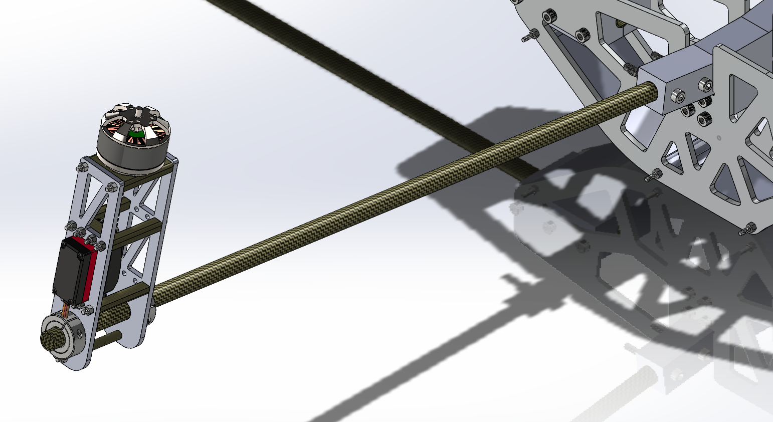

2/6/2023